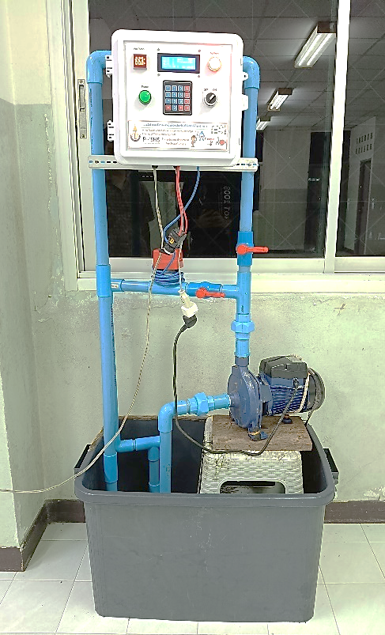

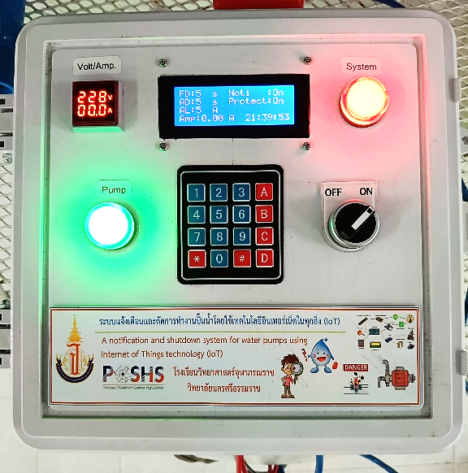

Thammanit Nooyimsai1* and Chayut Sapphakhao1

Tuanjai Archevapanich2 and Boonchana Purahong3

1 Princess Chulabhorn Science High School Nakhon Si Thammarat, 120 Nakhon Si Thammarat – Pak Phanang Rd., Bang Chak Subdist., Mueang Nakhon Si Thammarat Dist., Nakhon Si Thammarat 80330, Thailand

2 Faculty of Engineering and Architecture

Rajamangala University of Technology Suvarnabhum, 217 Nonthaburi Road, Suan Yai Subdistrict, Mueang District, Nonthaburi Province 11000, Thailand  
 3 School of Engineering at King Mongkut's Institute of Technology Ladkrabang (KMITL), 1 Chalong Krung 1 Alley, Lat Krabang, Bangkok 10520, Thailand

* pipenahni@gmail.com

**Abstract**

This project presents A notification and Shutdown system for Water pumps using Internet of Things (IoT) technology. It aims to prevent damage from uncommon pump operations, such as Dry-run or Overcurrent. The system tracks the condition of the pump using a power measurement sensor (PZEM-004T) and a water flow sensor (Flow Switch). It can automatically stop the pump and notify users through the Telegram app if it detects any issues. Through an intuitive interface, users can adjust the protection mode, power consumption limits and pump shutdown delay. It provides real-time notifications, allowing users to watch and confirmed that the system

**An IoT-Based Notification and Shutdown System for Water Pumps**

worked according to all settings with 100% accuracy. It sent notifications via Telegram and shut down the pump effectively when problems arose.This system can be used for water pump operations in homes, farms and factories to improve safety and increase water efficiency.

**Keywords:** notification system, shutdown system, water pumps, Internet of Things (IoT), Dry-run

**Introduction**

Water pumps are essential appliances that are widely used in both household as well as agricultural environments. One major issue that frequently occurs is the "Dry-run" condition, in which the pump is running even when there is no water flow. This condition leads to mechanical damage, overheating of the pump and excessive energy consumption. From a survey of Salacca farmers in Mueang district, Phatthalung province, it was found that leaves and other debris regularly clog water pipes, preventing adequate water flow while the pump is running. The pump's temperature rises extremely as it draws in air rather than water, ultimately leading to system failure.

To solve this problem, the research team developed A notification and Shutdown system that can detect unusual pump behavior, such as failing to draw or deliver water or abnormally high electrical power consumption. The system notifies the user and turns off the pump to stop additional damage when such conditions are detected.

The NodeMCU ESP8266 microcontroller is used as the main processing unit [1] in this study due to its advantages, which include low cost, lightweight design and lower power consumption compared to other platforms like the Orange Pi [2]. A pump shutdown delay, power consumption threshold and a damage prevention mode (Protect mode) have the three main operational components of the system that can be adjusted via an intuitive user interface.

**Materials and Methods**

A notification and Shutdown system was developed to prevent abnormal pump operation in two conditions: (1) Dry-run, when the pump runs without water flow and (2) Overcurrent, in that the pump uses more electrical current than is permitted. Three functional modules comprise the system's processing: protect mode, power consumption limit and pump shutdown delay. The telegram app is used to send notifications and Blynk, which was chosen for its simplicity for interface creation and control and was utilized to manage system commands [3][4]. The System architecture diagram is shown in Figure 1.

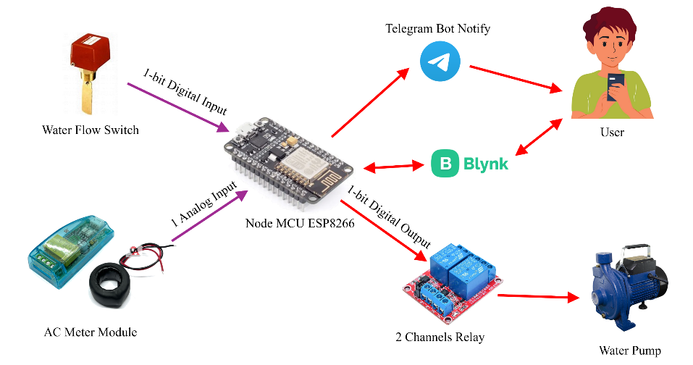

Figure 1: System architecture diagram

**System Installation**

A notification and Shutdown system was designed, constructed and installed. The installation process starts with attaching the flow switch to the water outlet pipe to track pump activity and make sure the water flows properly. The system cabinet, which is positioned above the pump using a PVC structure, contains the ESP8266 board, power measurement module and 2-channel relay. The flow switch signal wires are routed into the terminal block inside the cabinet and electricity is connected to power the system. Lastly, Wi-Fi configurations are set up to allow communication with the system and relay control wiring is connected so the system can cut power to the pump when necessary.

**System Operation**

In normal conditions, the NodeMCU ESP8266 checks that no abnormalities are present and allows the water pump to operate normally. When an abnormal condition occurs, the system activates to prevent pump damage. The operation can be divided into two scenarios, illustrated in Figure 2.

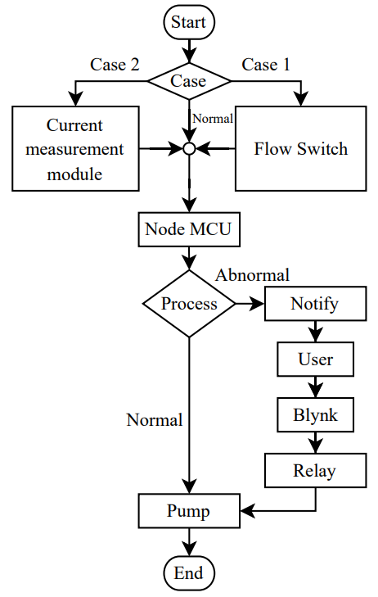

Figure 2: System operation flowchart

From Figure 4, the flowchart illustrates the system’s response under two abnormal conditions: (1) Dry-run - caused by clogging from leaves or branches obstructing the water pipe. (2) Overcurrent - caused by electrical faults such as short circuits. The NodeMCU ESP8266 receives sensor outputs and processes them to identify any unusual activity. If an abnormality is detected, the system sends a notification to the user via telegram, displays the warning on the Blynk interface and the liquid crystal display (LCD) at the front of the cabinet. Simultaneously, the system starts counting down based on the predetermined delay time. When the countdown ends, the relay module is triggered to shut down the pump. The pump can be restarted by pressing the "Reset" button on the Blynk interface or the "0" key on the 4x4 keypad located on the front panel of the control cabinet.

**Results of System Implementation**

Following the design and development of the system, the researchers carried out an operational assessment under both normal and abnormal conditions. When the system is activated by switching the main power switch at position 1 to the ON state, the red indicator light at position 2 illuminates, signaling that the system is powered and ready for operation. The keypad 4x4 located at position 3 is then used to configure system parameters according to user requirements, with all configurations displayed in real time on the LCD screen at position 4. The keypad functions include increasing or decreasing the Flow Delay using keys no.1 and no.4, adjusting the Amp Delay using keys no.2 and no.5, and modifying the Amp Limit using keys no.3 and no.6. The (*) key enables or disables Notify, the (#) key enables or disables Protect mode and key no.0 resets the system. Under normal operating conditions, the green indicator light at position 5 is illuminated, signifying that the water pump is functioning properly. At the same time, the digital panel meter at position 6 displays the real-time voltage and current being consumed by the pump. When an abnormal condition occurs, either the pump is running without water flow (Dry-run) or the electrical current exceeds the preset limit (Overcurrent) the system automatically shuts down the pump. Simultaneously, the green indicator at position 5 turns off and a notification is sent to the user via Telegram according to the detected abnormality. The system installation is shown in Figures 3, 4 and 5.

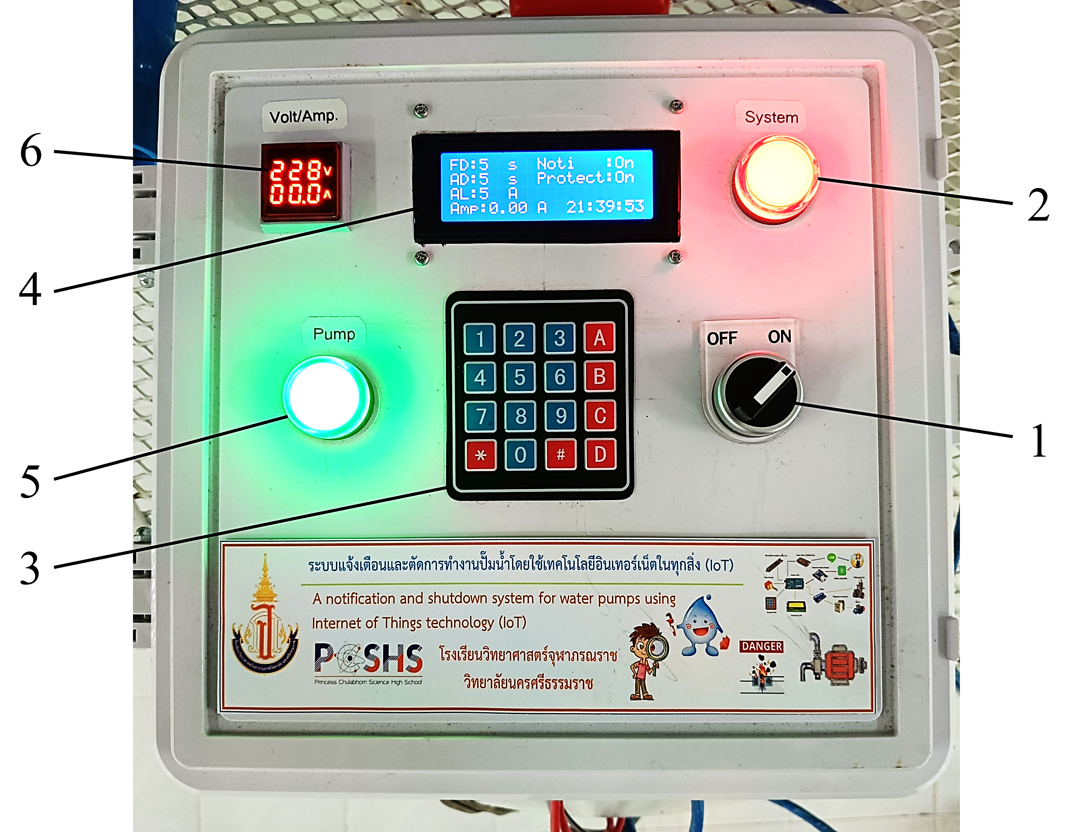

Figure 3: Front view of system cabinet

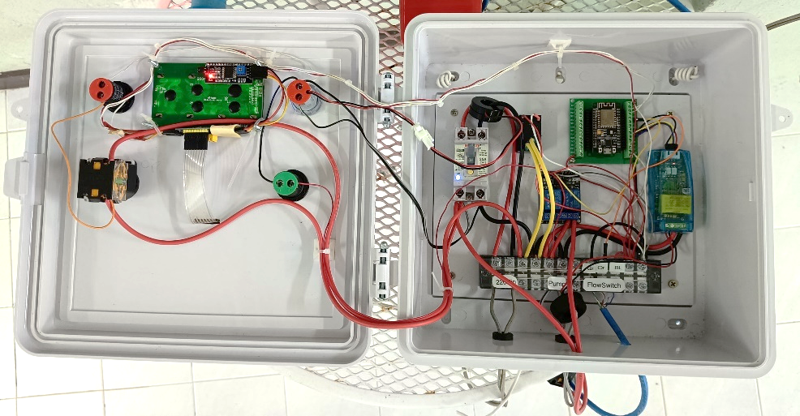

Figure 4: Inside of system cabinet

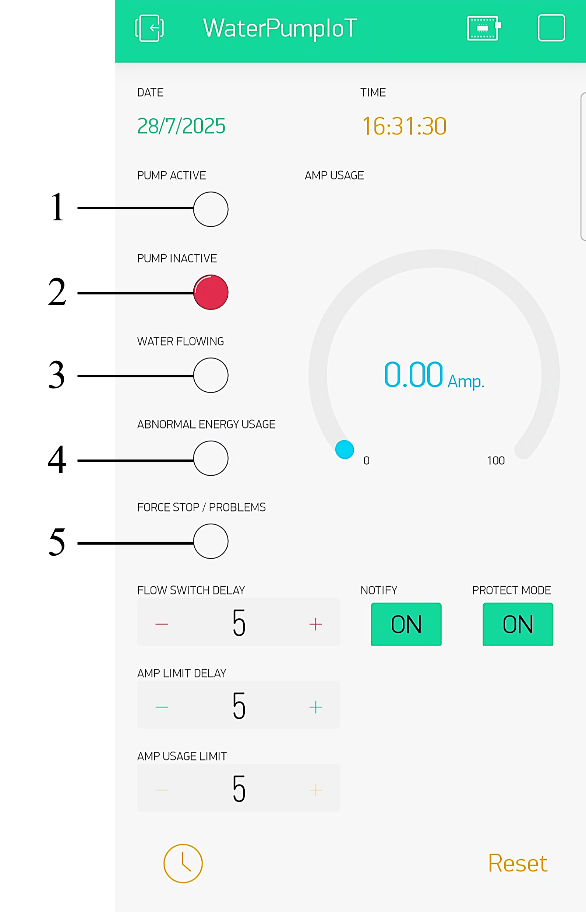

Figure 5: Blynk interface on Android

**Results and Discussion**

The experimental results indicated that the system behaved appropriately and performed effectively in detecting and responding to abnormal conditions in the pump. During normal operation, the pump was working fine and the green indicator at position 5 on the cabinet was lit. The first abnormal case studied was a Dry-running condition, that is, when the pump was on, but no water was flowing. In this case, the green indicator at position 5 on the cabinet turned off, the “Force Stop/Problems” indicator at position 5 lit up and a notification was sent via Telegram notify. The second abnormal case studied was an Overcurrent condition, that is, when the electrical current exceeded the preset limit. In this case, the green indicator at position 5 turned off, the “Abnormal Energy Usage” indicator on the Blynk interface at position 4 lit up, the “Force Stop/Problems” indicator at position 5 also lit up and a notify was sent to the user. The performance of the system under fault conditions with Protect Mode enabled is summarized in Table 1, wherein Condition (1) represents a dry-run condition, while Condition (2) represents an overcurrent condition. In 20 trials, the success rate was 100%.

Table 1: System performance under abnormal conditions with Protect Mode enabled

|  |  |  |
| --- | --- | --- |
| **System Respond** | **Condition** | |
| **(1)**  **Dry-run** | **(2) Overcurrent** |
| Shutdown water pump | 20/20  (100%) | 20/20  (100%) |
| Send notification  (Telegram) | 20/20  (100%) | 20/20  (100%) |
| Abnormal energy usage ON  (Blynk LED) | 20/20  (100%) | 20/20  (100%) |
| Force stop ON (Blynk LED) | 20/20  (100%) | 20/20  (100%) |

**Conclusions**

A water pump notification and shutdown system, through study and experimental evaluation, was able to meet its intended objectives. The system could detect abnormalities in operating conditions, including Dry-run and overcurrent states, effectively and notify users via Telegram Notify instantly. The system managed to perform an automatic shutdown of a pump when abnormalities occurred; hence, the possibility of pump damage was hugely reduced. The design of the Blynk interface gave a simple platform to the users for checking pump status and delay setup, power usage limit configuration. Along with the Flow Switch, the system ran smoothly and PZEM-004T served to provide measurement in power. Lastly, the results proved that the system prevented possible pump damage, reduced maintenance costs and enhanced overall efficiency in water management.

**Acknowledgments**

This project was successfully completed thanks to the kindness and support of Mr. Thapanawat Chooklin and, Mr. Taweewat Srisuwan and particularly Princess Chulabhorn Science High School Nakhon Si Thammarat, who kindly provided advice and suggestions on improving various aspects of the report book and contributed equipment until this research was successfully completed.

**References**

1. S. Nooyimsai, S. Getpan, J. Krohkaew, P. N. Crisnapati, Y. Thwe and K. Srion, “Efficient Energy Management: Exploring an Online Automated System for Electric Device Control”, 2023 18th International Joint Symposium on Artificial Intelligence and Natural Language Processing (iSAI-NLP), 2023.
2. M. Mubarik, A. Raza, H. Rashid, A. Zainuddin and Z. I. Abd Latiff, "Automatic Monitoring and Control System for Different Water Levels in Interconnected Multiple Twin Tanks with Dry Run Protection Using Microprocessor Orange Pi," 2022 IEEE Symposium on Wireless Technology & Applications (ISWTA), Kuala Lumpur, Malaysia, 2022, pp. 47-52.
3. Deenadayalan T., J Jasmine Shirley, R. Prajapati, P. Singh, A. Biswas and U. Soni, "An IoT-based Home Automation System using Node MCU and Blynk IoT App", 2023 International Conference on System, Computation, Automation and Networking (ICSCAN), 2023.
4. S. Nooyimsai, J. Thaloy, P. Jansengrat, W. Janratchakool, J. Krohkaew and P. N. Crisnapati, “Enhancing Breeding Control: The IoT-Driven Automated System for Budgie Farming”, 2023 11th International Conference on Cyber and IT Service Management (CITSM), 2023.